Web Services
Web services extend the World Wide Web infrastructure to provide the means for software to connect to other software applications. Applications access Web services via ubiquitous Web protocols and data formats such as HTTP, XML, and SOAP, with no need to worry about how each Web service is implemented. Web services combine the best aspects of component-based development and the Web, and are a cornerstone of the Microsoft .NET programming model.
Global XML Web Services Specifications
Web Services Specifications Index Page
Web services specifications compose together to provide interoperable protocols for Security, Reliable Messaging, and Transactions in loosely coupled systems. The specifications build on top of the core XML and SOAP standards.
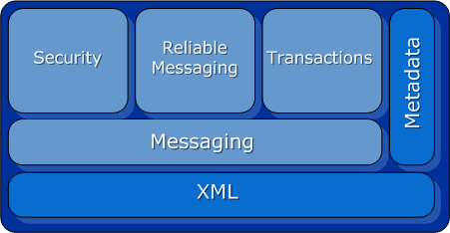

Specifications
Messaging Specifications
SOAP
WS-Addressing
MTOM (Attachments)
WS-Enumeration
WS-Eventing
WS-Transfer
SOAP-over-UDP
SOAP 1.1 Binding for MTOM 1.0
Security Specifications
WS-Security: SOAP Message Security
WS-Security: UsernameToken Profile
WS-Security: X.509 Certificate Token Profile
WS-SecureConversation
WS-SecurityPolicy
WS-Trust
WS-Federation
WS-Federation Active Requestor Profile
WS-Federation Passive Requestor Profile
WS-Security: Kerberos Binding
Web Single Sign-On Interoperability Profile
Web Single Sign-On Metadata Exchange Protocol
Reliable Messaging Specifications
WS-ReliableMessaging
Transaction Specifications
WS-Coordination
WS-AtomicTransaction
WS-BusinessActivity
Metadata Specifications
WSDL
WSDL 1.1 Binding Extension for SOAP 1.2
WS-Policy
WS-PolicyAssertions
WS-PolicyAttachment
WS-Discovery
WS-MetadataExchange
WS-MTOMPolicy
XML Specifications
XML
Namespaces in XML
XML Information Set
Management Specifications
WS-Management
WS-Management Catalog
WS-ResourceTransfer
Business Process Specifications
BPEL4WS
Specification Profiles
Devices Profile
WS-I Basic Profile
Columns Extended Data Type [AX 2012]
Help Text: Number of columns
Alignment: Auto
Base Type: Integer
Base Type Properties
Allow Negative: Auto
Analysis Default Sort Property: Ascending
Analysis Default Total Property: No
Analysis Grouping Property: Auto
Analysis Usage Property: None
Auto
Displace Negative: Auto
ID: 2932 (non-default)
Model: Foundation (non-default)
Rotate Sign: Auto
Show Zero: Auto
Sign Display: Auto
XML
Extensible Markup Language (XML) is the universal format for data on the Web. XML allows developers to easily describe and deliver rich, structured data from any application in a standard, consistent way. XML does not replace HTML; rather, it is a complementary format.

